6. a

|  |  |  |  |  |  |  |
| --- | --- | --- | --- | --- | --- | --- |
| **Rtop** | **Rterm** | **Vinc** | **Vref** | **Vtrans** | **Vref/Vinc** | **Vtrans/Vinc** |
|  |  |  |  |  |  |  |
| *[Ω]* | *[Ω]* | *[Volts]* | *[Volts]* | *[Volts]* | *[Unitless]* | *[Unitless]* |
| 37.90 | 4.50 | 0.42 | -0.26 | 0.02 | -0.62 | 0.05 |
| 37.90 | 12.50 | 0.42 | -0.22 | 0.11 | -0.52 | 0.27 |
| 37.90 | 21.50 | 0.42 | -0.18 | 0.17 | -0.43 | 0.41 |
| 37.90 | 30.20 | 0.42 | -0.16 | 0.20 | -0.38 | 0.48 |
| 37.90 | 38.60 | 0.42 | -0.14 | 0.26 | -0.33 | 0.63 |
| 37.90 | 55.10 | 0.42 | -0.06 | 0.32 | -0.13 | 0.77 |
| 37.90 | 61.00 | 0.42 | -0.05 | 0.38 | -0.11 | 0.90 |
| 37.90 | 72.60 | 0.48 | -0.04 | 0.49 | -0.08 | 1.02 |
| 37.90 | 81.80 | 0.48 | -0.02 | 0.52 | -0.04 | 1.08 |
| 37.90 | 90.40 | 0.48 | 0.00 | 0.54 | 0.00 | 1.13 |
| 37.90 | 111.60 | 0.48 | 0.02 | 0.59 | 0.04 | 1.23 |
| 37.90 | 131.80 | 0.48 | 0.04 | 0.62 | 0.08 | 1.30 |
| 37.90 | 149.30 | 0.48 | 0.06 | 0.64 | 0.13 | 1.33 |
| 37.90 | 169.20 | 0.48 | 0.08 | 0.65 | 0.17 | 1.35 |
| 37.90 | 190.00 | 0.48 | 0.10 | 0.68 | 0.21 | 1.42 |
| 37.90 | 210.00 | 0.48 | 0.13 | 0.68 | 0.28 | 1.42 |
| 37.90 | 296.00 | 0.48 | 0.15 | 0.70 | 0.32 | 1.46 |
| 37.90 | 400.00 | 0.48 | 0.17 | 0.72 | 0.35 | 1.50 |

b/d.

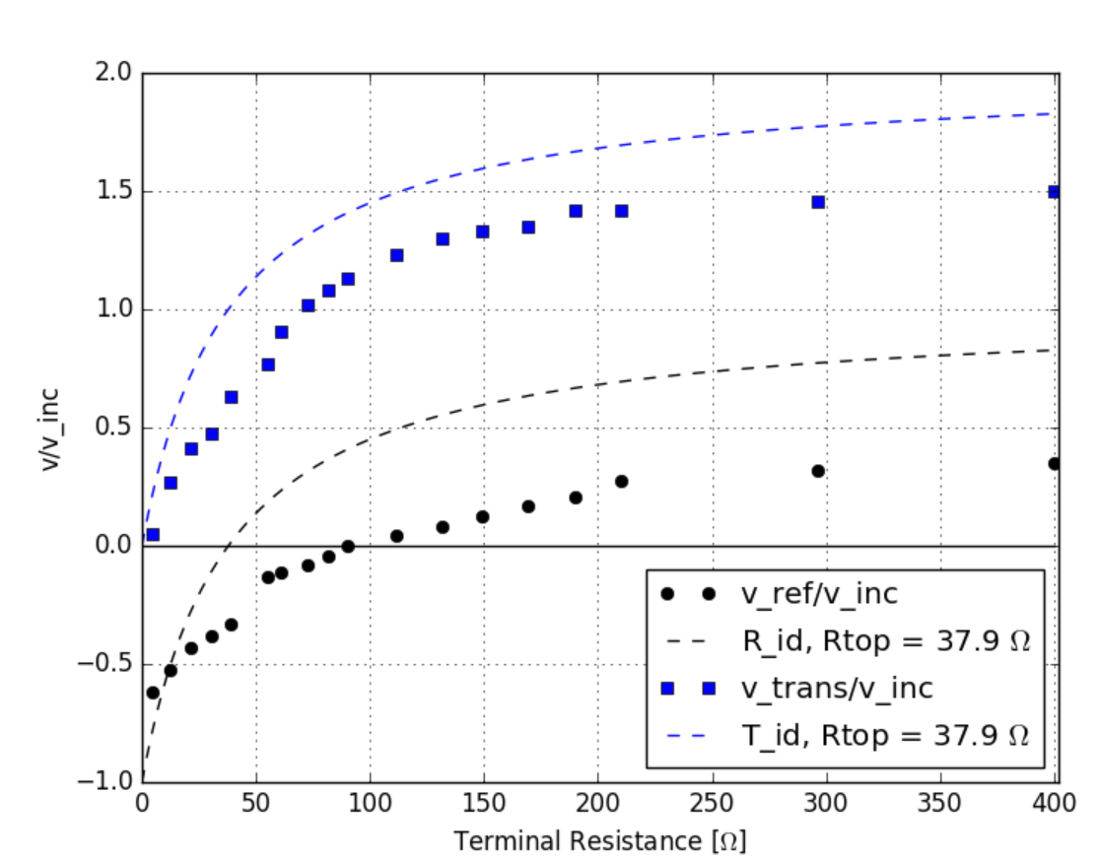

c. The experimental and theoretical data agree particularly well for the transmission coefficients where the shapes are consistent with one another. Neither is perfect and as shown in class I expect the theoretical model will agree better with experiment after damping is considered as a part of the system. As is, we only consider the “wave equation” from Kirchoff’s law for the infinitesimal current loop in the coaxial cable we expect another term that involves the factor Γ.

Bellow I include the code I used to generate my plots as well as a sample of the oscilloscope output for reference:

